INSTALLATION OF GRAPHICAL USER INTERFACE IN FEDORA SERVER AND DEFAULT SETUP
Open the command line of your server and login to your account
Install GUI of your choice (we’re installing XFCE) using the command; sudo dnf install xfce4* and run it.
NOTE; incase this command doesn’t run you can use; sudo dnf groupinstall “xfce Desktop” or sudo dnf install @xfce-desktop-enviroment –y
Set it as default use the command; sudo systemctl set-default graphical.target
Set display manager use the command;sudo dnf install lightdm –y
Enable display manager use the command; sudo systemctl enable lightdm
Set graphical target use the command; sudo systemctl set-default graphical.target
Reboot the server use the command; sudo reboot
Once its booted it should open automatically to this page in the image below
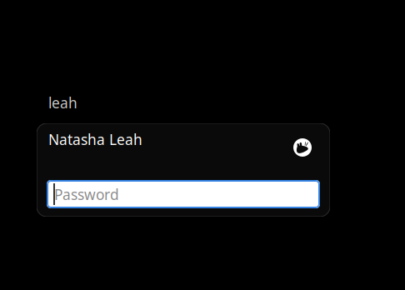
Input password and it will load the page below
